2/4/2025

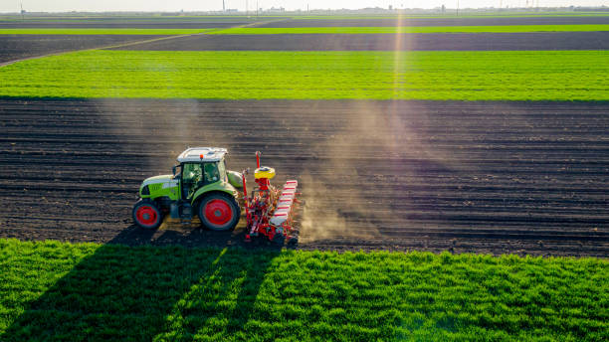

PROJECT BY MD. SHAKIL HASAN

edgE PROGRAM UNIVERSITY OF BARISHAL

Project-2025

Village Name-Apoorva Nagar

Calculation of profit/loss of crop of 25 Farmer's on total cultivated land in one year.

Table of Contents

1.Introduction- 1

2.Project Goals- 2

2.1 Income expenditure analysis of 25 of farmers. 2

2.2 Comparison of the amount of land income of Rice , Eggplant, Mazie cultivation. 2

2.3 Net profit and assess the financial condition of village farmers. 2

3. Data of the crops cultivated by the farmers- 2

4. Analysis of Income Expenditure and Net Profit in Graph and Chart- 3

4.1 This is a Bar chart of Total income and expenditure comparaison- 4

4.2 This is a Histogram of Net profit- 4

4.3 This is a Pie chart of all cultivated crops Apoorva nagaor- 4

5. Formula of Average Income, Expenditure, Net Profit- 5

5.1 Average Income- 5

5.2 Average Expenditure- 5

5.3 Average Net Profit- 5

6. Highest and Lowest Net Profit- 5

6.1 Highest Net Profit- 5

6.2 Lowest Net Profit- 6

7. Project findings and Recommendation- 6

8. Conclusion- 6

# 1.Introduction-

The project is designed to provide financial stability and development to the farming families of Apoorva Nagar village. Presented here is a detailed analysis of the income-expenditure, land use and net profit of 25 farmers for one year focusing on the cultivation of three crops—rice, brinjal and maize. The project will assess the profitability of each crop, the efficiency of resource allocation and the overall financial status of farmers. By organizing the data in Microsoft Excel, visual presentation in PowerPoint and detailed reports in Word, the research will improve farmers' productivity and suggest sustainable agricultural policies. The aim of this initiative is to advance the agricultural economy of Apurba Nagar through data-based decision making.

# 

# 2.Project Goals-

## 2.1 Income expenditure analysis of 25 of farmers.

1. Average income-112596.15 BDT.
2. Expenditure income-37230.76 BDT.

## 2.2 Comparison of the amount of land income of Rice , Eggplant, Mazie cultivation.

1. Total Rice of land-81.5 Acre.
2. Total Eggplant of land-98.5 Acre.
3. Total Maize of land-95 Acre.

## 2.3 Net profit and assess the financial condition of village farmers.

1. Total net profit-1884000 BDT.

# 

# 3. Data of the crops cultivated by the farmers-



# 4. Analysis of Income Expenditure and Net Profit in Graph and Chart-

## 4.1 This is a Bar chart of Total income and expenditure comparaison-

## 4.2 This is a Histogram of Net profit-

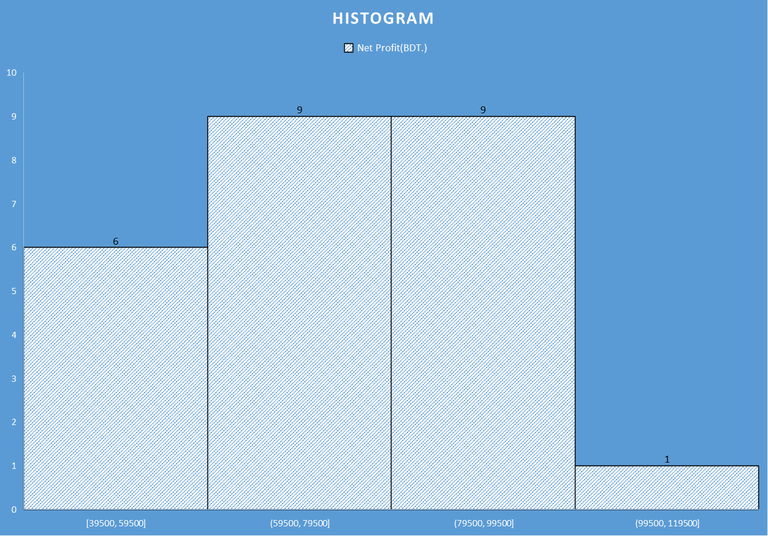

## 4.3 This is a Pie chart of all cultivated crops Apoorva nagaor-

# 5. Formula of Average Income, Expenditure, Net Profit-

Use of Average Funtion-

## 5.1 Average Income-

* =Average (L9,L9:L33)

## 5.2 Average Expenditure-

* =Average (M9,M9:M33)

## 5.3 Average Net Profit-

* =Average (N9,N9:N33)

# 6. Highest and Lowest Net Profit-

## 6.1 Highest Net Profit-

* Use of MAX Function (N9,N9:N33)
* Highest net profit-102500 BDT.
* Name of farmer -Jamal

## 6.2 Lowest Net Profit-

* Use of MIN Function (N9,N9:N33)
* Lowest net profit-39500 BDT.
* Name of farmer-X-bin

# 7. Project findings and Recommendation-

* The financial condition of the farmers in this village is good.
* The farmer does not incur any loss in growing the crop.
* Corn crop is the most profitable in this village.
* Farmers will benefit more if corn crop is increased in this village.
* More profit can be made if fertilizers are applied according to rules in crop cultivation.

# 8. Conclusion-

Through this project a detailed analysis of income-expenditure and crop-based farming of 25 farmers of Apoorva Nagar village is presented. The analysis shows that *maize* is the most profitable , followed by paddy and brinjal. However, a large section of farmers are facing financial challenges due to *high production costs* (seeds, fertilizers, labor costs) and *fluctuating crop prices in the market*. Although the overall financial condition of the village is stable, some farmers survive on minimal profits.

KEY RECOMMENDATIONS-

1. Crop Diversification: Encouraging cultivation of high value vegetables or fruits by reducing dependence on only rice-eggplant-maize.

2. Cost Reduction: Increase use of organic fertilizers and reduce production costs by using locally produced seeds.

3. Government Support: Providing support to farmers through subsidies, training, and market linkages.

4. Digital Intervention: Providing information about market prices, weather forecast, and modern methods of farming through mobile apps.

If these measures are implemented, the income-profit ratio of the farmers of Apurba Nagar village will improve and sustainable agricultural management will be developed.